# Telco Customer Churn Prediction Report

## 1. Problem Definition

Customer churn is a critical issue for telecom companies, as retaining existing customers is more cost-effective than acquiring new ones. This project aims to predict customer churn using machine learning models, allowing the company to take proactive measures to retain at-risk customers and improve customer satisfaction.

## 2. Data Collection and Exploration

The dataset used in this study is the 'Telco Customer Churn' dataset, which contains customer demographic information, service subscription details, and account history. The dataset was preprocessed to handle missing values and convert categorical variables into numerical representations. Key exploratory data analysis (EDA) steps included:  
- Checking for missing values and imputing where necessary  
- Converting the 'TotalCharges' column to numeric and handling null values  
- Analyzing the correlation between different features and churn

- Visualizing the distribution of churn using count plots

## 3. Model Building

Two predictive models were built and evaluated:  
- Logistic Regression: A simple yet effective classification algorithm for churn prediction.  
- Random Forest Classifier: An ensemble learning method that improves prediction accuracy and handles non-linearity in the data.  
  
Model Performance Metrics:  
- Accuracy Score : 0.80  
- F1 Score : 0.54  
- Classification Report  
  
The Random Forest model outperformed logistic regression in terms of accuracy , making it the preferred model for churn prediction.

## 4. Visualization and Interpretation

Key visualizations included:  
- Churn distribution plot

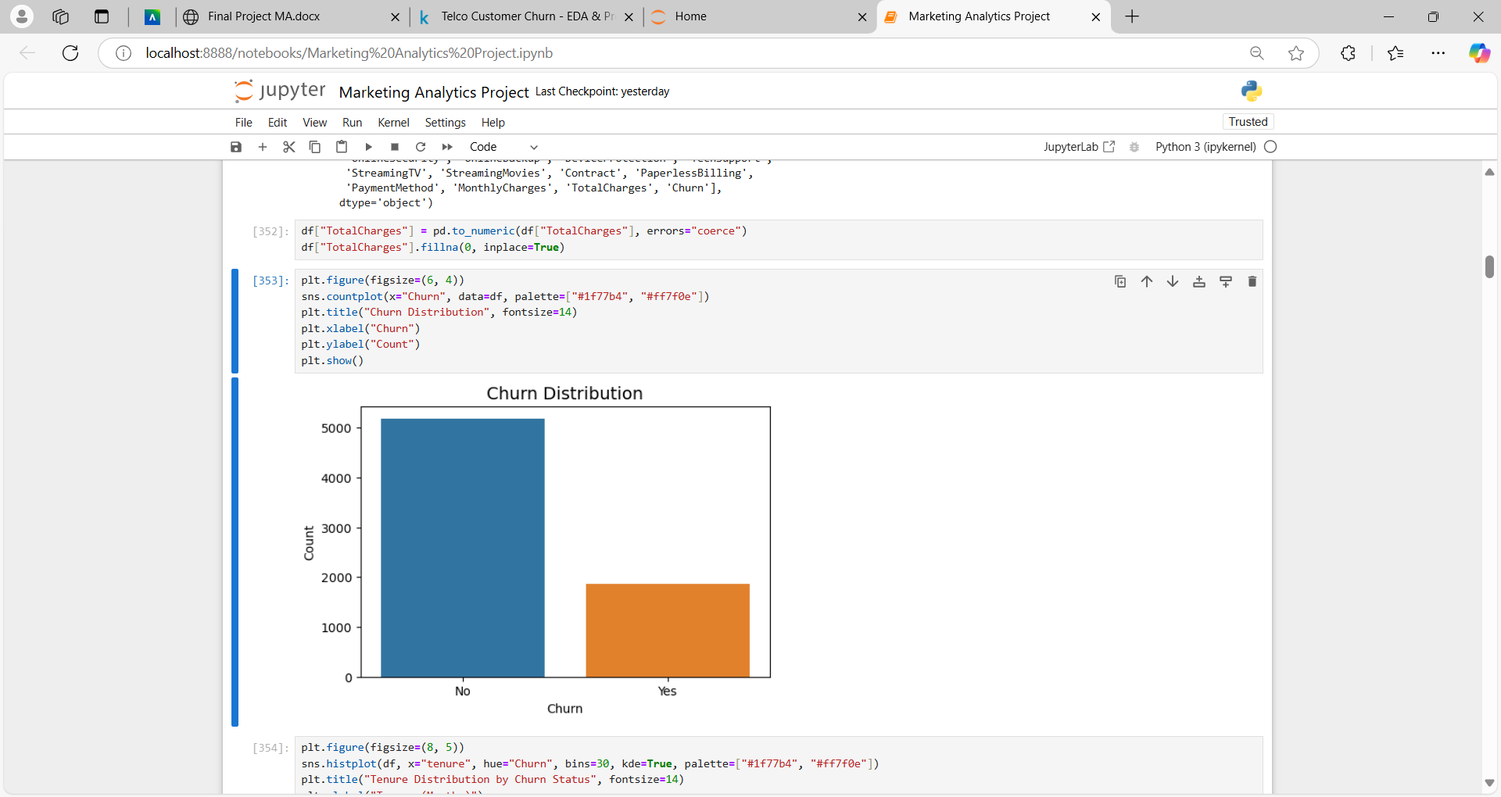

- Feature importance plot

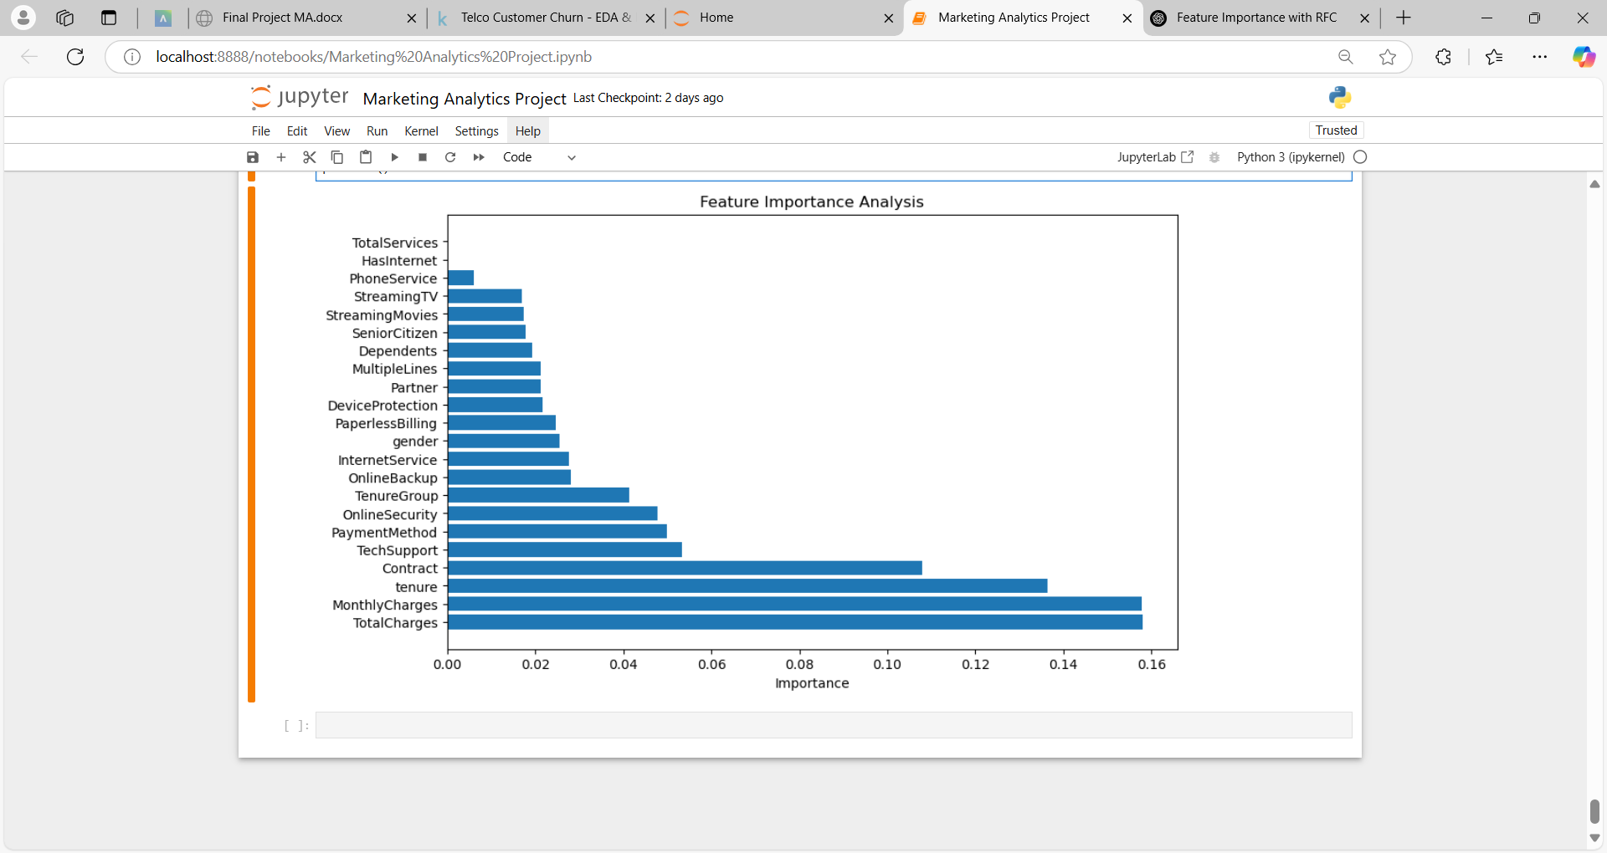

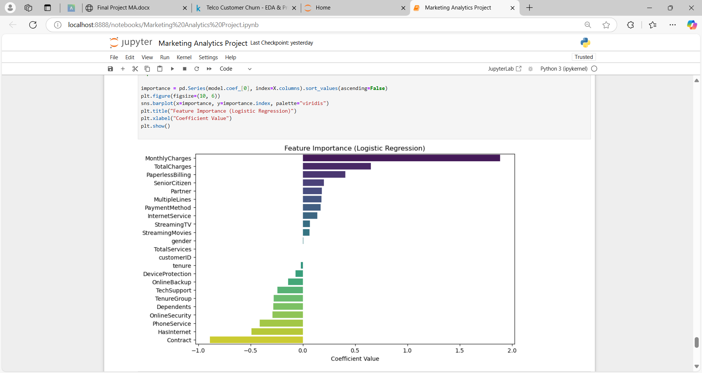

- Correlation heatmap showing relationships between variables

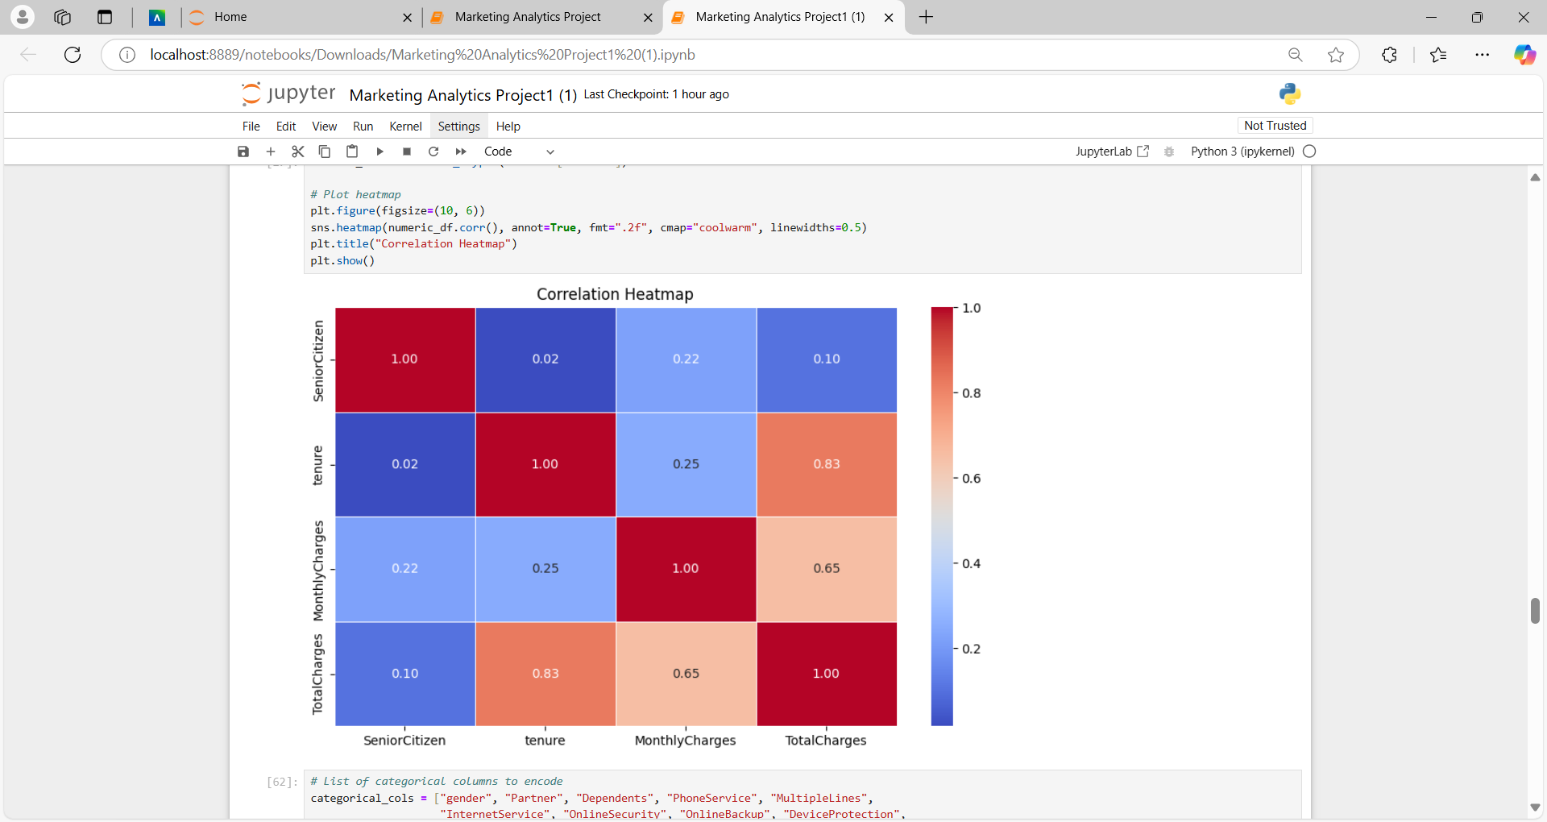

-Confusion Matrix

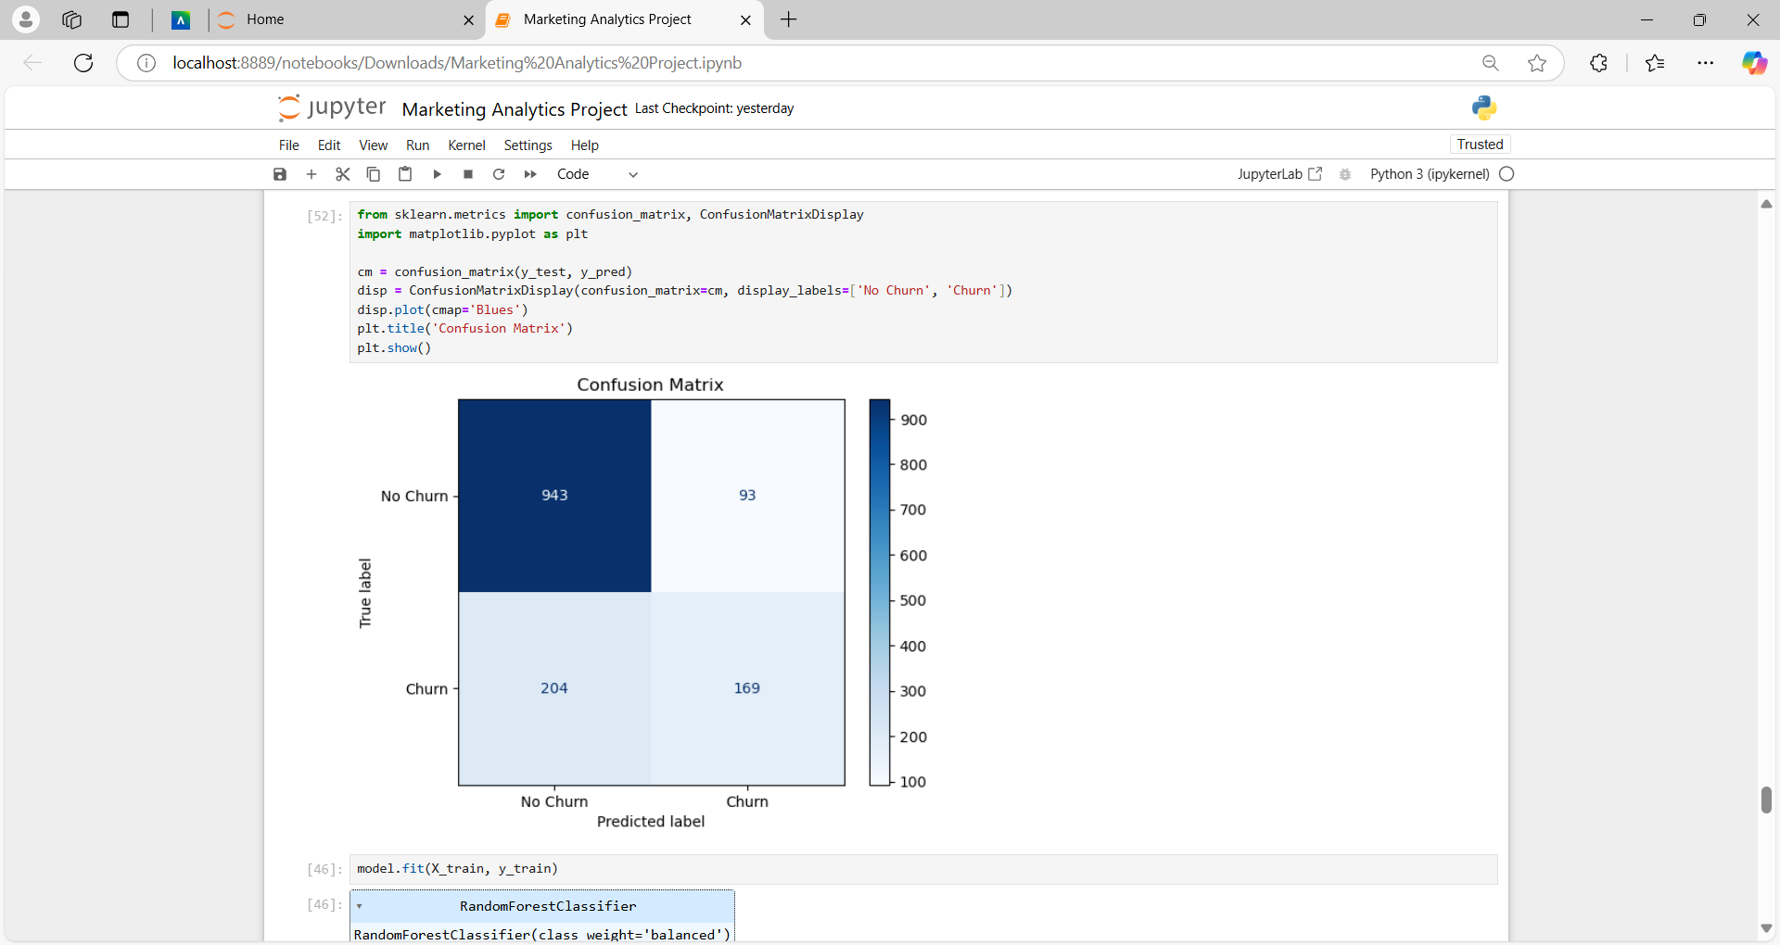

Business Implications:   
- Features such as contract type, tenure, and monthly charges significantly influence churn.  
- Customers with month-to-month contracts and high monthly charges are more likely to churn.  
- Retaining customers with discounts or incentives for long-term contracts could reduce churn rates.

## 5. Recommendations

Based on the model's predictions, the following actionable recommendations are suggested:  
- Offer long-term contract discounts to month-to-month customers.  
- Provide personalized retention offers to customers identified as high churn risks.  
- Improve customer service interactions for at-risk customers by addressing their pain points proactively.  
  
By implementing these strategies, the telecom company can enhance customer retention, reduce churn, and increase revenue.